Coati Console Project

Prototype designs discussion document

Background

Instantaneous interpreting technology is traditionally expensive, a significant barrier for many groups. This was one of the issues Coati was set up to address, and the motive for a previous Coati project to make available open source designs for 'spiders', a hardware system that can be used for simple instantaneous interpreting needs at meetings etc. The more complicated interpreting requirements of large conference etc. have been meet by Coati with equipment which was developed twenty years ago for the European Social Forum. The equipment is now dated, become unreliable and hard to maintain. Over the years Coati has been approached by many groups wanting similar consoles but Coati has been unable to help. For these reasons Coati is now planning to develop open source designs for consoles.

Instantaneous Interpreting consoles explained
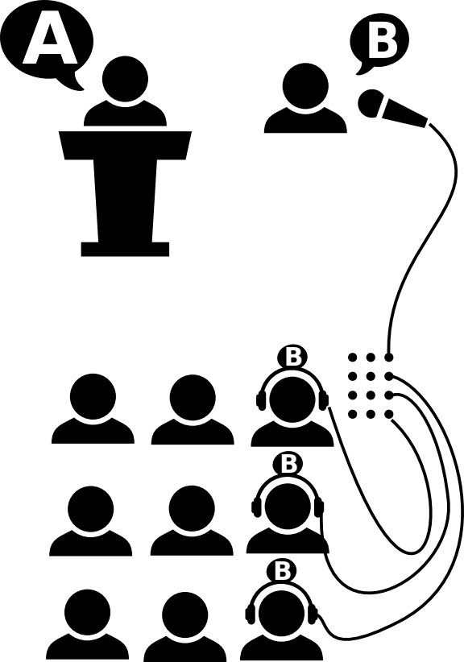
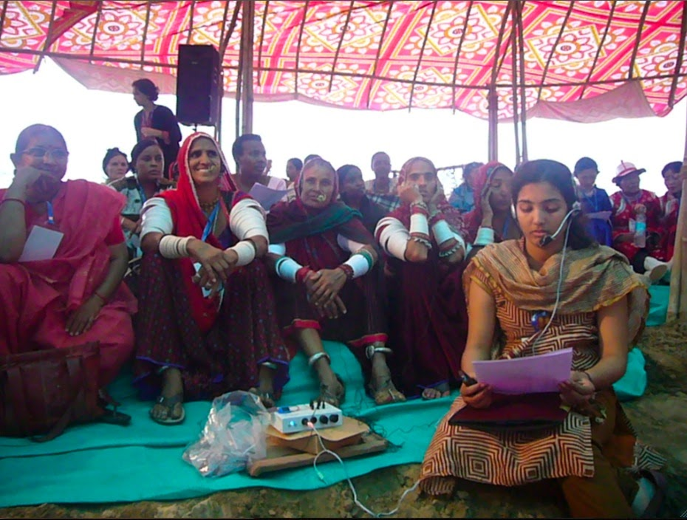
At its simplest, instantaneous interpreting is one person listening to one language they understand, and interpreting what they hear into another language for other listeners who understand that language but not the first. In some situations it may be done with no equipment, just a huddle of people straining to hear, or a number of groups gathered around a number of different interpreters. Microphones and headphones (along with associated amplifiers and cables) may be used to help people to hear what they need over the extra noise of extra people all talking at the same time. As the number of languages involved grows, so does the number of interpreters needed, and the complication of ensuring everyone gets to hear what they can understand. The additional complexity requires equipment specifically designed to address the requirements of the situation, routing audio from different speakers via different interpreters and delivering their interpretation to the appropriate groups of listeners. Additionally, this equipment must be capable of being quickly and easily reconfigured when speakers switch into different languages, and the system must also be able to be scaled up for larger groups of people.
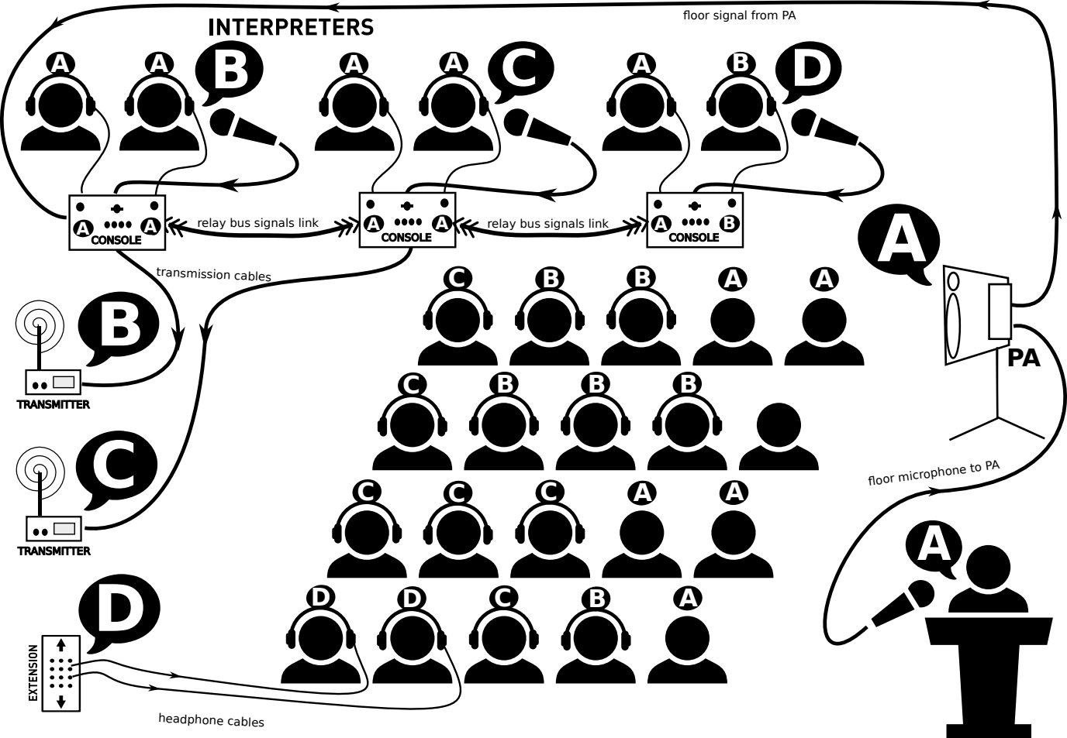
The equipment developed specifically for the task is known as an interpreter console. Commerical consoles cost a great deal of money but regardless of cost, console all do the same thing - first routing audio to an interpreter from a person speaking, and then, as that person interprets, routing what the interpreter says to a group of people who understand the language now being spoken. Multiple translators work in what are known as booths, each translating into different languages for different groups of people. However, since not all translators speak every language, it is often necessary for the words of a speaker to be translated by first one translator, and then another, before being delivered to some groups of listeners. This means that the audio being delivered to the various booths must include not only the speaker, but often also other interpreters.
Basically an interpreter console can be considered as a specialist routing system for audio that is dedicated to the specific needs of conference interpreting. Audio from a specific persons microphone is brought into the console though a selected input and routed to an interpreter's headphones via an amplifier, and then their own microphone carries their voice, via another amplifier and through a selected output to be routed to other interpreters and/or other listeners. The ability to select the appropriate input and output allows very complex interpreting needs to be met.

In the scenario illustrated bellow there are four interpreter booth, three with a team of two interpreters who take turns to avoid exhaustion, and one with lone personal interpreter working for a specific delegate who will speak occasionally and also needs to understand what all the other speakers are saying. It requires five languages to cover the needs of the participants, but the majority are covered by three languages. Only a couple of people need language D so in this example they are supplied via headphone cable extensions while everyone else receives their interpreting via radio transmitters plugged into the consoles. The delegate who speaks language E has their own wireless equipment and interpreter who needs to access to the translations from the other interpreters in a language they understand, so they are also assigned a booth with a console.

The illustration shows a moment in which the microphone has been given to somebody with a question for the speakers, and they speak language B. About a third of the audience understand B and do not need interpreting for at this moment. In all the booths containing interpreters who understand B they are interpreting the languages of their listeners, A D and E. The interpreters in the C booth don’t understand B so they listen to the interpretation into A instead. By this means, everyone gets to understand the question being asked. When the speaker at the podium who speaks on E answers the question, the interpreters will be able to hear the interpretation in A, and then interpret from A into the appropriate language for their group.

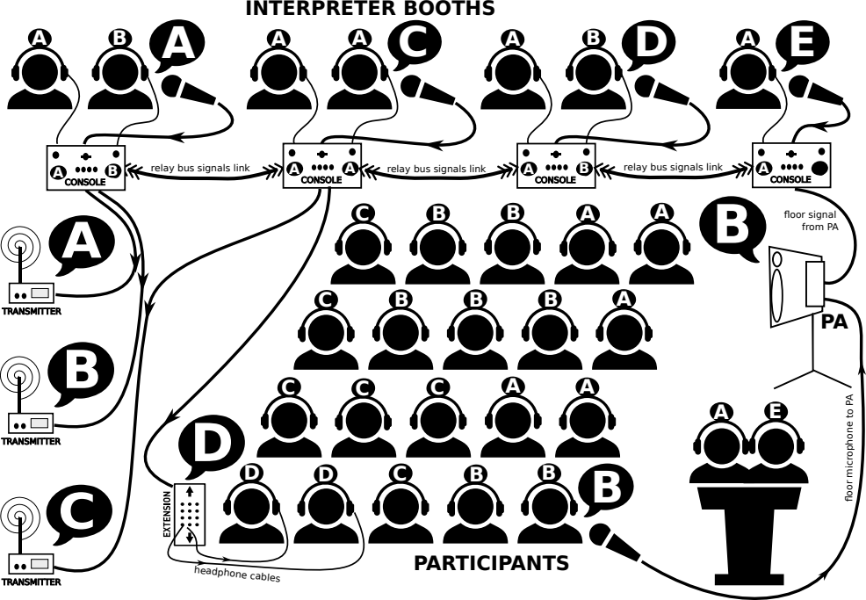
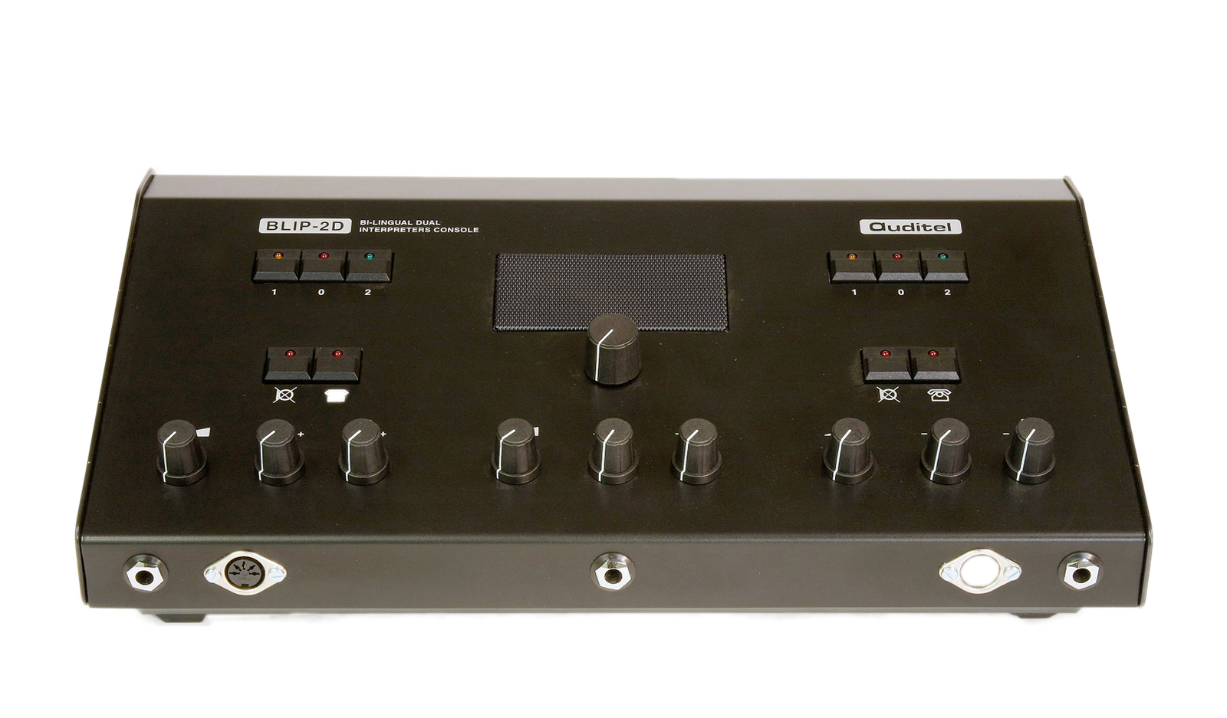
Commercial interpreter consoles

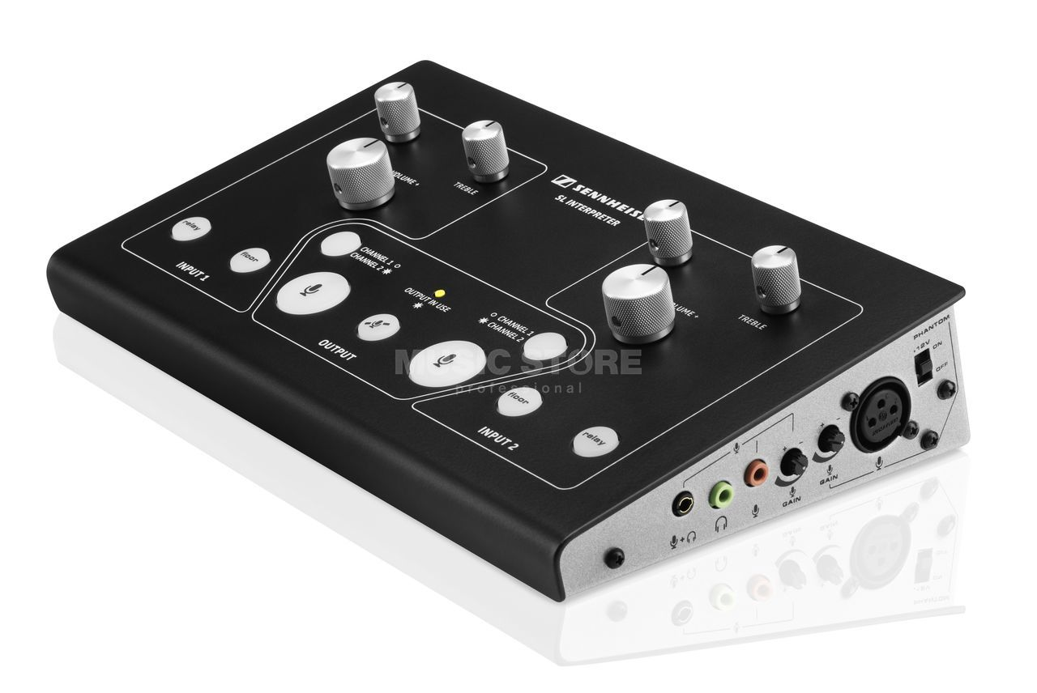
The are no shortage of commercially available interpreter consoles, in fact the available models seem to have multiplied in the last few years. They range from simple devices with limited potential to extremely sophisticated digital units unnecessary numbers of potential simultaneous channels, LCD screens, programmable buttons and many more fancy features.

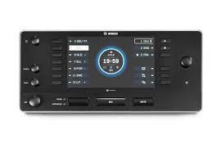
They all share the basic essential abilities described previously, and they also all share extraordinarily high prices! Even dated second-hard units fetch hundreds of euro each, while the simplest of new units exceed a five hundred and the top end gear is well over a thousand for each console. This is well beyond the reach for most social movement and even rental costs would be extraordinary. These are some of the reasons the Coati collective came into existence, attempting to fill the need for affordable access to these technologies.

Alternatives
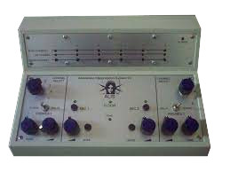
The ALIS (Alternative Interpretation System) project was born out of the Social Forum Process and the BABELS initiative, with the aim to allow activists in the social movement to express themselves in the various social forums and initiatives, even if they don't speak the "usual colonial languages" (English, Spanish, French, Portuguese…) The ALIS console was developed and used for the European Social Forum back in 2004 and again in 2008. When Coati was formed in 2009, the collective tracked down and purchased all the remaining consoles that had been stashed away gathering dust in a warehouse somewhere.

Information about the ALIS consoles can be found here https://www.babels.org/spip.php?article47, and some discussion about planning for use of ALIS equipment at the 2008 ESF can be found here https://www.babels.org/spip.php?article258

The consoles were designed to be daisy chained together by a cable carrying seven audio channels. The daisy chained consoles also required a dedicated distribution box which provided the inputs and outputs for the entire system and consisted of 15 1/4" jack sockets and volume controls (15 knobs). An output from the PA would be plugged into the distribution box and from there to the daisy chained consoles.

When the consoles were switched on (using a button) one of six audio output channels could be selected (using one of six additional buttons). Some clever electronics were used so that when one console had selected an output bus, that channel was shown as 'busy' on other consoles to help prevent multiple people trying to speak on that one.

One of the issues with these consoles was that although six buses provided more than enough relay channels for most situations, the corresponding six independent outputs on the distribution box were often insufficient for the number of languages needed. Coati addressed the problem by modifying some of the consoles so that they had a local output separated from relay bus which enabled more flexibility in linking additional outputs.
Two translators could work on each console, each able to independently select (using a combination of one toggle switch and and six position rotary switch) which audio source they heard on their headphones, either the current speaker using the venues floor microphone, or any one of the six channels used by other translators. Each translator also had independent control of their headphone volume and tone (two more rotary knobs x2). Additionally two microphones could be plugged in and the interpreters could individual adjust their volume (two more knobs) or mute it temporarily (by holding down one of two buttons) or switch it off completely using a switch usually found on the microphone itself. They could also switch off either microphone from the console itself (using yet two more buttons) and if both microphones were switched off on the console, the audio from the floor would be routed through the consoles selected output channel instead.

As you can appreciate, the consoles had a lot of knobs, dials, switches and buttons, twenty one in total, and it was not uncommon for people to twiddle or press the wrong thing and wonder why no sound was coming out, or why they could hear nothing or hear the wrong thing. Additionally, as time has passed, switches and connections have broken or only work intermittently, creating additional confusion and disruptions. Only limited repairs are possible as no schematics are available, and since it's not practical to make new ones to the same design, the number of consoles and distribution boxes available for use has dwindled as they break beyond the means to repair.

A New Open Source Design

It's clear that there is a need for new affordable consoles, and designing them provides a good opportunity to address some of the problems with the old ones. There were over twenty knobs, dials, switches and buttons on the old consoles, not to mention those on the distribution boxes. Reducing this number would not only reduce the potential for confusion but also reduce the number of things to get broken, and probably cut costs too. It would also probably mean the console could be made smaller and lighter, which would mean they could be packed into smaller cases and help to reduce transportation costs.

Cutting the number of controls is not all good and may mean compromise, for example, getting rid of the two knobs for tone control obviously means no control over tone, however weighting the value of tone control against the benefits of reducing the number of knobs seems worthwhile. Another example might be the two switches provided for switching between the 'floor' input and the 'relay ' inputs. These switches can easily eliminated by adding the 'floor' input to the 'relay' selection switch, after all it is essential just another input option. The compromise here is that it is that it would no longer be quite so quick and simple to switch back to the original relay channel after a switch to floor, but again, that's probably a small price to pay for removing a couple more switches.

Another worthwhile compromise would be having only one rather than two microphones. Only one is used at any one time and by having only one you element not only a mic input socket but also all the superfluous duplicate controls. That means one less volume control, one less mute button, and one less mic on/off button, not to mention all the extra internal components no longer required, and one less mic! That all represents a significant saving in constructions costs, as well as reduced potential confusion, and the only compromise is that the two interpreters will occasionally need to pass the microphone over to their team mate (and this might require adjustment of microphone volume level to account for different voice levels).

Eliminating the need for the distribution boxes would also be beneficial, with not only one less device needed, but also reducing the need to carry spares in case one fails. Instead of having the inputs and outputs on the distribution box, they can be placed on the consoles themselves. The compromise is that it massively increases the total number of connector ports required overall (and therefore also increasing the component cost), but it also massively increases flexibility and redundancy. For example, when laying out booths and consoles, the input from the floor can be taken to whichever console is most convenient for the cable run, rather than only to the end of the chain with the old system. Additionally, transmitters can be plugged into the outputs of any console, so no need to try to squeeze everything in around the distribution box one a table at one end of the line of booths. And if a connection on one booth is faulty, just move to the same output on the next console.

The daisy chain and distributor box system required the uses of cables never designed to carry the audio signals, and based around 9 pin RS232 serial connectors. It's likely that they were chosen as they were a relatively cheap off the shelf cables at the time, and contained enough wires to carry multi audio channels. They are however fundamentally unsuited to the task, creating an easy path for crosstalk and external interference to add noise to the signals, and are no-longer even especially cheap or easy to source. For these reasons the new design would be better off finding an alternative, but what affordable and easy to obtain multi-pin connector should be used and what cables are capable of carrying multiple audio channels with minimal crossover or other interference at low cost? Answers those questions become much easier if you abandon the idea of having six separate language buses plus floor. Although it may seem like a fairly major compromise at first, having only three relays is sufficient for most circumstances, and it is fairly easy to cater for more relay languages by other means on the rare occasion it is required. This compromise means the cable and connectors chosen need only deal with four audio pairs rather than seven!

These compromises represent a balance between creating a new console design that incorporates all the essential functions of both the old consoles and the distribution boxes, while also being less cluttered with controls, smaller, lighter, more flexible and providing redundancy. On top of all this, the design needs to be simple and flexible enough for people anywhere to build or repair their own consoles, with easy access to open source schematics and building instructions available in a variety of languages.

Our solution

The basic design of the new consoles can be described as consisting for two main parts, the input side (you can think of it as the incoming, receiving, or monitoring side) and the output side (outgoing, send, transmission). Both parts can be further broken down into audio signal amplification and audio signal routing/switching. Amplifying input signals is required to ensure they are at a level sufficient to enabling listening via headphones. The output also requires amplification of microphone signal to a level suitable for onward transmission. The switching involves the ability to select which audio sources are being listened to on the receive side, and on the transmit side, which 'channel' the console transmits to.

The receive side is duplicated (as two interpreters need independent control of what they hear). There needs to be two separate input switching controls allowing selection of either 'floor' or one of the three 'relay buses'. On the transmit side we only need one channel selection control, for switching between those same three 'relay buses' and an additional output we will call 'local'.

The three 'relay buses' are shared across the receive and transmit side of the consoles, along with 'floor' channel (local is not shared). The four shared buses are connected to a pair of RJ45 connectors which enable many consoles to be chained together so that all the consoles have access to those same four channels. For simplicity, all these signals are routed via a signal hub.
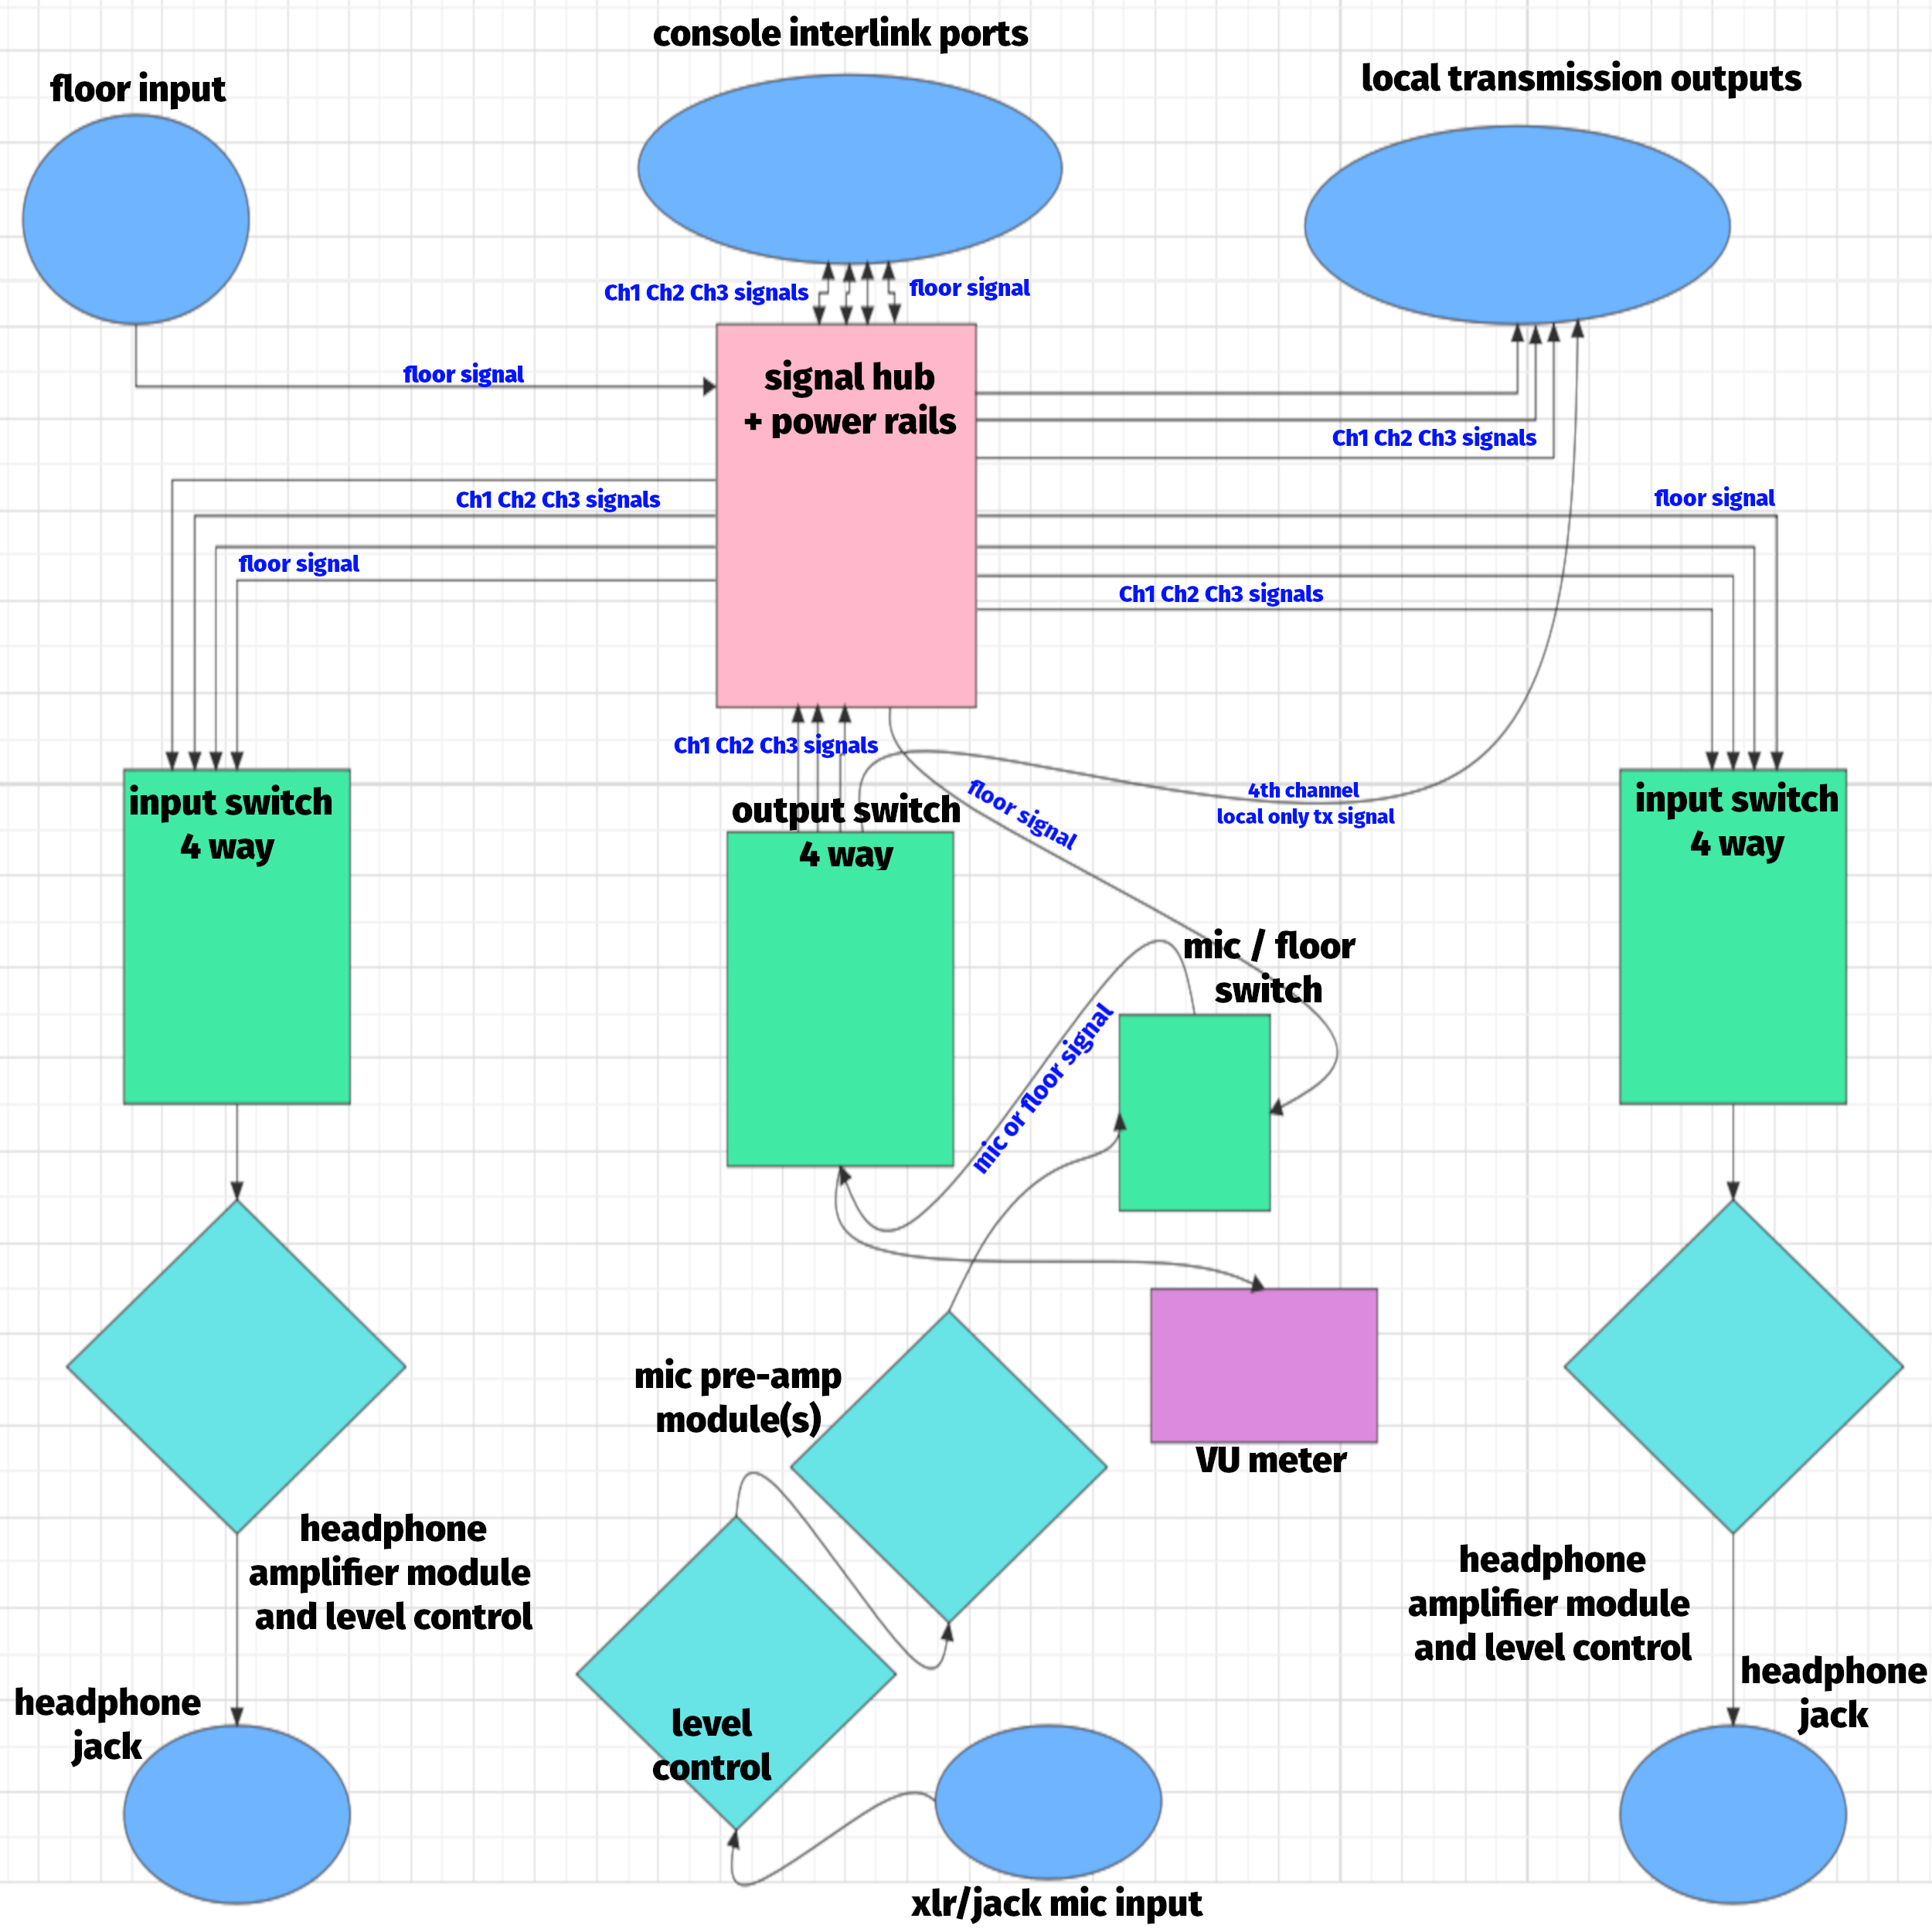
Setting up

In use, a technician will daisy chain a number of consoles together using unshielded twisted pair cable such as commonly available CAT5, and connect an audio cable from the venue PA into the 'floor' input on any one of the console. This makes the floor signal available on all of the consoles, along with the three shared language relay buses. Radio transmitters (or a wired headphone distribution system) will be plugged into the relevant outputs on any of the chained consoles, or, as required, attached to the 'local' output of specific consoles providing additional languages.

Since this extra output has no corresponding shared bus, it is not available as a relay channel. Experience tells us that it is extremely rare to have a situation in which more than three relay channels are required. However, one way to address this possibility and provide additional flexibility would be to provide one or all of the consoles with five position input selection switches instead of four. The extra position would be connected to a dedicate independent local input port, much like the existing local output port. On the rare occasion an additional relay is needed, a cable (or radio) can be used to connects one consoles local output port to another's local input port.

A microphone will be plugged into each console (XLR or TRS jack) and the technician will pre-select the appropriate input and output channels according to the requirements of the interpreter booths. During sound checks the technician will adjust the microphone volume. The LED sound level indicator will give a visual clue of whether it needs further adjustment when the interpreters are making use of the console but ideally the control will be out of the way and interpreters encouraged not to fiddle with it.

The interpreters will plug in their headphones (3.5mm) and adjust their individual listening volume to suit their preferences as and when desired. There are two headphone outputs with individual volume controls, as typically two interpreters work together at one console as a team. During operation, the interpreters may also need to switch between listening to relay bus channels or the listening to the floor signal. They may also need to mute the microphone (which can usually be done using a switch on the microphone itself) or switch off the microphone and route the floor channel through to their assigned output channel when the current speaker is using the language they had been translating into. Sometimes, as interpreting needs change, they may also need to change the output of their console to another channel.

I/O connection summary

To sum up the required connectors on each console: a DC power socket (12vDC barrel type), two headphone outputs (TRS 3.5mm stereo jacks), one microphone input (XLR/TRS 6.5mm jack), a line level input for floor (mono TRS 6.5 jack or x2 RCA), two i/o ports for daisy chaining to other consoles (x2 RJ45) and four outputs for transmission (x8 RCA, or maybe x4 mono TRS jacks). Optionally there could be outputs for recording devices (x2 RCA or 3.5mm TRS), and if the previously mentioned idea about having five way input selection switches was adopted, there’d also be the independent local input port (x2 RCA or 6.5mm TRS).

Note: Floor is typically provided from the venue PA system and could either be stereo or mono depending on the mixing desk. Hopefully mono output is available but we should probably consider the possibility it could be either. A cheap method to sum a stereo pair to a mono signal is to terminate two 1K ohm resistors to the Left and Right channels and then tie them together. Therefore the best approach may be to provide a stereo TRS socket, with the channels combined internally. However, what happens if you plug a mono plug into the stereo socket - it would short one channel. For this reason it might be best not to use TRS but stick to x2 RCA, or provide both options.
Console construction

The above describes the basic functions and features of the consoles but the design criteria can be met in a number of ways using different hardware solutions. The Coati Console project will involve building a number of prototypes in order to evaluate the various hardware options, and the ultimate intention is to have built at least four functioning prototypes for testing purposes.

Our intention is to met the design criteria by following a modular approach to construction, using off-the-shelf, pre-assembled ‘plu and play’ components as much as possible. The idea is to make replicating the design as easy as possible without the need for electronics skills. We also aim to make trouble shooting and repair much easier by following this approach.

Pre-amp modules choices

Part of the evaluation process will be testing the different headphone and microphone pre-amp modules that are commonly available. These pre-amps modules can easily be swapped in and out of the prototypes during the evaluation process in order to assess which is most suitable.

Virtually all the modules available are stereo devices but we don't really need stereo as all the shared bus channels will be mono in order to keep to a minimum the number of wires required in the daisy chain cabling. Headphones are generally stereo but since the input from the relay buses will be mono, in theory we don't need both of the channels in the stereo headphone pre-amps, and could potentially drive two headphones using a single pre-amp rather than use two. This is something we can explore during prototyping but the cost savings would be very minor so maybe not worth doing unless on a really tight budget.

Other modules / features etc

Some of the prototypes will include features not described in the basic design criteria in order to explore their desirability. These include ideas such as built-in rechargeable batteries to maintain channel selections during momentary accidental power loss in design using active switching components, and potentially even enable mains free operation. Another idea is to incorporate FM radio receivers to provide an additional relay language input for greater flexibility.

Audio switching choices

The most significant differences between prototypes will be the different methods of achieving audio signal switching. The switching can be done using either 'passive' mechanical switches, or 'active' mechanical relays or solid state devices such as transistors and integrated circuits. The prototypes will enable us to evaluate the pro's and con's of each in terms of cost, construction simplicity, ergonomics, noise, crosstalk, reliability etc.

It might seem logical that simple mechanical switches will be the cheapest and simplest to put together but actually good quality multi-pole multi-throw switches are not cheap and the cheaper ones may not be reliable or be more prone to crosstalk. They may also cause noise when switching, especially as the contacts get old and worn with use. Clicks and pops during switching may not be a big deal on the receive side but it should certainly be avoided on the transmit side.

Relays are what is generally used in professional audio equipment for signal switching. They are noise free and surprisingly reliable. However they are not cheap and if we use them on both the receive side and the transmit side we would need twelve of them! A cheaper alternative can be found in solid state analogue switch ICs such as the CD4051, 4052, or 4066 which cost about tenth of the price of relays. There are some additional components needed to use these ICs, and buttons or switches to actually operate them, but that is also true of relays. Both probably also need some method to indicate their current state when switching, most likely LEDs.

A potential bonus of using either relays or their solid state equivalents is that they can be operated by logic circuits. This means that instead of needing a four way switch to select from four channels, we can for example, use 'up/down' buttons to move through the channels or even have a single push button that cycles through the channels sequentially. Even more interesting is the possibility to use a microcontroller, which although possibly adding additional cost and complication, would open the doors to incorporating advance features sometimes found in commercial interpreter consoles.

Use of microcontrollers

One of the advanced features that will be explored will be the ability to lock relay bus selection so it is not possible for more than one console to select the same output channel. This feature requires some method by which the consoles share status and the use of microcontrollers with built in Wi-Fi is one way to do this. Whether the additional cost and complication of using microcontrollers is worthwhile is something that needs to be assessed but the possibilities are very exciting.

The ESP32 has built in Bluetooth and WiFi and costs less than ~Є7. Along with making it possible to add relay bus protection, many other features become possible, for example, it would provide a technician with the ability to remotely control console output bus selection if required, maybe even adjust microphone levels. The ESP32 can record sound and play it back, so the feature found on high end commercial interpreter consoles, whereby the user can playback the last few words spoken by the speaker, may also become a possibility.

There a cheap ESP32 modules (under 20 euros) with built in LCD touch screens. These would enable sophisticated control of the input and output channel selection, with programmed labelling of the channels by their assigned language, and at a glance viewing of the current status. Control of microphone volume level could be ‘hidden’ in the menu system, leaving it accessible but reducing the chance of accidental tampering. An on screen clock and timer could help interpreters keep track of their shifts, and it’s even possible that the screen could display the schedule of speakers. It would even be possible for interpreters to send each other on screen messages via the built in Wi-Fi, be it jokes or interpretations questions or suggestions etc.

These advanced features are currently beyond of the scope of this project and have not been budgeted for in the current prototyping project, however embedding these feature-rich microcontrollers into the console design does open the door to future development and ideas not yet considered, perhaps for example, using WiFi or Ethernet to connect consoles and using digital sound protocols to share a larger number of relay languages without the current limitations of cabling and hardware switching, or simplify hybrid conferences with online streaming elements. Who knows what might be possible.

Significant technical issues

There are a number of specific technical issues that should be considered and addressed. These revolve mostly around the noise, distortion, clipping, crosstalk or other types of interference known to cause problems on the existing equipment being used by Coati and similar collectives. Noise is generated internally, often due to poor quality components or design. It may manifest as humming noise, perhaps from badly designed or poorly regulated power supplies. Clipping is usually caused by attempts to over-drive amplifiers with an unreasonably high level signal but could also be down to poor choice of components or ill-conceived design with inadequate headroom. Distortion may also be a result of inappropriate design choices, poorly matched components etc.

Crosstalk is common in multi channel equipment where different signals are in close proximity. Switches in signal selection stages are one common possible source of crosstalk. In our consoles another likely source may be the cables intended to carry the shared relay language buses between consoles. These cables, and other cables such as the power cables, floor input, and outputs to transmitters or spiders, are also potential places for the introduction of external interference such as poorly shielded power supplies, florescent tube lighting, and radio frequency interference from our own transmitters. A number of techniques exist to address these possible avenues of external interference. For example, shielding, decoupling capacitors, ferrite beads and isolation transformers.

Balanced and unbalance signals

External interference to audio signal cables is commonly addressed though the use of balanced audio signals and shielded cables. Without getting too technical, using balanced signals allows for what is known as common mode rejection, a very effective way to reduce the impact of outside interference on signals travelling down a shielded pair of wires. Balanced audio is usually the preserve of professional audio equipotent and is not a feature of either the Coati spiders nor, to our knowledge, the ALIS consoles. Long cable runs of low power audio signals in interference rich environments is exactly when balanced audio is exactly what balanced audio systems are built for. There is no doubt that it would be highly beneficial in the console project, especially for the i/o ports for daisy chaining the consoles together.

The floor input is another strong candidate for balanced audio, however the same can be achieved by using a balanced cable from the balanced output on the venue PA and running it through either a DI box or a small mixer placed as close aa possible to the console and then as an unbalanced signal into the floor input.

Since neither the radio transmitters nor the spider use balanced audio, there is no point in providing balanced audio at the transmission outputs on the console. Cable lengths with need to be kept short to reduce potential interference issues. Where it is unavoidable that long cable runs are used, DI boxes or smaller mixers could be utilised along with shielded balanced cables.

There are several ways to implement balanced audio within the consoles, using either passive or active techniques. Since or proposed design features shielded two channel cables and connectors for virtually all the signal paths, we could potentially implement balanced audio throughout the entire system simply by using differential pre-amps in both the headphone output stages and the microphone input stage. We have located a couple of suitable headphone preamp modules but don’t seem to be able to find affordable off-the-shelf pre-amps for dynamic microphones. However, even if we did find them, this approach means all out outputs would be balanced by default, and we;d need some way to unbalance them for the unbalanced inputs in our existing equipment, either internally or externally. This need not be a big deal, just worth taking into account.

Another approach would be to use ‘balun’ (balanced unbalanced) audio transformers. These can be pretty cheap for the kind of frequencies and signal levels we are using. They have the additional advantage of providing earth isolation which will help eradicate buzzing noises caused by ground loops. The transformers could be placed in several locations, for example on the input side of the output selection switch, or the output side of the input selection switches. This would involve just three transformers and mean that all the internal amplifier stages remain unbalanced, but everything coming in or going out of the console is balanced. Again, this approach means that ALL inputs and outputs would be balanced, including the outputs we will used unbalanced.

Placing the transformers only on the ports we want to be balanced addresses this issue, however it means using two more transformers for each console. We’d need one on the floor input, then four more for the i/o relay buses. However, if we placed them on the signal hub board, the floor input, and the floor bus on the i/o relay bus connectors could probably share the a signal transformer. If there is a disadvantage to this, I can’t currently think of one. With the transformers built into the signal hub board, it’s possible to decide whether the output ports should be balanced or not depending on whether the connectors for these are placed on one side of the transformers or the other. If JST connectors are placed on both sides, it would be a fairly trivial operation to reconfigure consoles for balanced or unbalanced outputs depending on the needs of the users.

As it appears to be the cheapest and most flexible approach, we propose a second stage of prototyping that explores the use of audio transformers on the signal hub. The additional cost per console would be under 5 euros and ultimately reduce the need of more expensive external devices such as DI boxes and mixers.

Cost estimates

As previously mentioned, commercial units, purchase new, appear to cost at least 500 euros and often well over 1000. It may possible on a rare occasion to get lucky and find used consoles, perhaps a bankruptcy auction, but searches of online auction sites suggest prices would still be high and it would be very difficult to find sufficient numbers of compatible consoles so you could easily get stuck with an insufficient number of consoles and be forced to buy more of the same at a much higher price, assuming you could find them at all.

https://www.ebay.com/itm/295265851314 $110
https://www.ebay.com/itm/284027829659 $330
https://www.ebay.com/itm/234858673549 $350
https://www.ebay.com/itm/174497840087 $900

For the consoles we are developing we estimate, at the current stage of developing design and evaluating prototypes, that component cost will be between 40 to 80 euros, most likely the lower end. That doesn’t include a case or power supply. We estimate a suitable case will probably cost about 30 euros and a power supply under 5. That makes the total hardware cost of each console (excluding microphones and headphones etc) somewhere around 80 euros. If labour were factored in, the cost would obviously increase. At this stage it’s hard to estimate how long assembly will take, but assuming you could put together at least one console in an eight hour day (which seems realistic), and assuming a fifteen euro an hour nominal labour cost, the total cost should probably end up at no more than 200 euros per console.

It’s entirely probably that when building large enough numbers, total component cost will fall significantly because the proportion of cost that is shipping will be reduced. Additionally, assembly time is also likely to fall as those putting the consoles together should get familiarised with the process and establish an efficient routine.

Regardless of the exact final cost, they will be massively more affordable than any of the commercial systems, either new or used.

Conclusions

Regardless of the exact internal hardware and design used to construct the consoles, the basic functionality should remain the same and by maintaining the final recommend design specifications, differing consoles should hopefully still be able to be linked together and operate as described. This means different people can build consoles to their own budget or preferences but they should still remain compatible with console built by others to the same basic design principles. There may be some differences in choice of input or output connectors but that should not prevent different console from being hooked up together using adapters where necessary. Some consoles might also include features not included in the basic design principles (for example: a fifth input channel; built in stop watch countdown; mic mute; built in microphone etc) but that should still not preclude them from working with other consoles.

The modular design lends itself to not only to easier assembly and comprehension of the design, but also to rapid troubleshooting and repair using module exchange rather than component level repairs. Additionally, modifications and improvements can easily be made and adopted by others as time goes on, perhaps bringing even cheaper construction or improvements in sound quality or rejection of interference.

When we talk about output levels, we are not specifically talking about a standardised ‘line level signal’ as such, just signal levels which meets the requirements of however many consoles have been daisy-chained together. The level is primarily set on the output of the front of house mixer going to the floor input of a console (perhaps adjusted by a small mixer before the console). This level may be considered ‘line level’ in the loosest terms, as it delivers sufficient signal for the headphone pre-amps on all the consoles daisy chained together. The level on the shared buses and outputs is adjusted to be of similar level using the mic volume controls on each console. These levels are not intended to meet any standard for line level, which differ considerably between professional and consumer equipment, and the requirements of the devices used for the further transmission (spiders, radio transmitters etc.) may also vary. It may be that a small mixer is required between console and onward transmission to ensure suitable a suitable level is delivered for further distribution.

